**Studying Individual’s and Group’s Scoio-Emotional Artifacts in Medical Teams towards Improved Patient Safety: A TeamSTEPPS Approach**

Prepared by

**Sreekar Krishna**

Center for Cognitive Ubiquitous Computing

Arizona State University

Tempe AZ 85281

&

**Dr. Bhavesh Patel M.D.**

Mayo Clinic Hospital

Phoenix AZ 84054

June 2010

Table of Contents

1. Introduction 3

1.1 TeamSTEPPS: 3

1.2 Socio-Emotional Underpinnings to TeamSTEPPS: 4

1.3 Research Directions: 4

2. Basics of human communication 4

2.1 Group Dynamics: 5

2.2 Leadership: 6

3. State-of-the-art Affect Sensors 7

3.1 On-body Physiological Sensors: 7

3.2 Environment-based Affect Sensors: 8

3.2.1 Video-based Affect Recognition: 9

3.2.2 Audio-based Affect Recognition: 10

4. Research Activities: 11

4.1 The Mayo Clinic Multidisciplinary Simulation Center: 12

4.2 Automated monitoring of group dynamics to determine communication breakdowns 12

4.2.1 Research Hypothesis: 12

4.2.2 Research Methodology: 12

4.2.3 Impact on TeamSTEPPS: 13

4.3 Automatic evaluation of the social affinity between team members 13

4.3.1 Research Hypothesis: 13

4.3.2 Research Methodology: 13

4.3.3 Impact on TeamSTEPPS: 14

4.4 Leadership evaluation and nomination through long term monitoring of teams and individuals 14

4.4.1 Research Hypothesis: 14

4.4.2 Research Methodology: 14

4.4.3 Impact on TeamSTEPPS: 14

Conclusion: 14

# Introduction

The importance of studying a group of physicians entering a medical situation as a single operating system began to appear in the focus of behavioral scientists with the publication of the Institute of Medicine (IoM) report titled *To Err is Human:* *Building a Safer Health System* [1]in Dec 1999. One of the four core messages from the report indentified that patient life is lost not because of the failure of an individual, but due to the failure of the system as a whole. When it comes to the physicians, the failure point of a system has been identified to be the breakdown in the team that is responding to the medical emergency [2]. Since the report came out in early 2000, Agency for Healthcare Research and Quality (AHRQ) and Department of Defense (DoD) have focused on the team failure from an Evidence-Based Medicine [3] perspective and released Team Strategies and Tools to Enhance Performance and Patient Safety (TeamSTEPPS™) [4][5] as the national standard for team training in health care.

## 1.1 TeamSTEPPS:

TeamSTEPPS is based mostly on Crew Resource Management (CRM) [6] models of teamwork that has been successfully demonstrated to reduce accidents (and loss of life) by decreasing errors within the cockpit and at the ground maintenance stations. TeamSTEPPS were based on earlier research sponsored by AHRQ and DoD, prominenet of which is the report by Baker et. al. [7], which focused on understanding the nature of teamwork training and sustenance. The results of such studies lead to the development of a *trainable* and *measureable* model of medical teamwork that was derived extensively from academic models. Figure 1 shows the TeamSTEPPS instructional framework on which the rest of this report is based on.

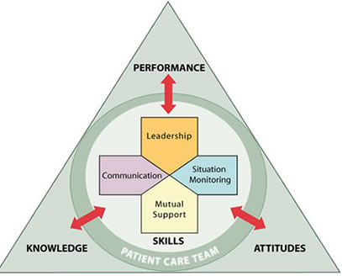

**Figure 1:** The instructional model for TeamSTEPPS.

Adopted from AHRQ website on TeamSTEPPS

## 1.2 Socio-Emotional Underpinnings to TeamSTEPPS:

As seen from Figure 1, the skills component TeamSTEPPS focuses on the individual physician and the team’s ability to work together as a system. Leadership, Communication, Situation Monitoring and Mutual Support were all derived from earlier DoD and AHRQ lead studies in medical team management and are based on the underlying principles of: Team Leadership [8], Mutual Performance Monitoring [9], Backup Behavior [10], Adaptability [11], Team/Collective Orientation [12], Shared Mental Model [13] [11], Mutual Trust [14] and Closed loop Communication [10]. For a detailed analysis of each of these principles, please see King et. al. [4]. Most of these principles are in turn derivatives of the social skill set of the individuals who make up the medical team that is responsible for the patient safety. It have been shown that in cases of medical errors, leading to loss of life, communication breakdown between one or more team members resulted in an avalanche of problems eventually resulting in death.

## 1.3 Research Directions:

Recent developments in the area of Socio-Behavioral Engineering, miniature on-body physiological sensors, environmental affect sensors and socio computational technologies offers immense opportunities for enhancements in three important areas of TeamSTEPPS training and evaluation. These include:

1. Automated monitoring of group dynamics [15] to determine communication breakdowns.
2. Automatic evaluation of the social affinity between team members (Sociometric [16] evaluation of the team members)
3. Leadership evaluation and nomination through long term monitoring of teams and individuals.

# Basics of human communication

Human communication process involves complex interplay of verbal and non-verbal cues. Nearly 65% of all human interpersonal communications happen through non-verbal communication cues [17]. In a bilateral interpersonal interaction, while speech encodes all the information, non-verbal cues facilitate an elegant means for delivery, interpretation and exchange of this verbal information. For example, eye gaze, iconic body gestures, hand gestures, and prosody enable effective and seamless role play in social interpersonal interactions. People communicate so effortlessly through both verbal and non-verbal cues in their everyday social interactions that they do not realize the complex interplay of their voice, face and body in establishing a smooth communication channel. This translates into the teamwork attitude of every individual in the medical team. Nearly 72% of non-verbal communication [18] takes place through visual cues encoded on the face and body of the interaction partners (see Figure 2). Thus, it is not only the verbal exchange that the medical team has to focus on, but it’s also the non-verbal cues that the team has to watch out for.

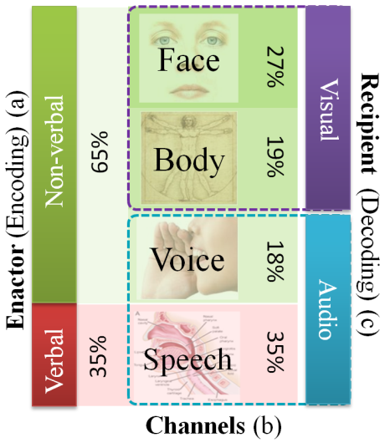

**Figure 2**: Relative importance of a) verbal vs. non-verbal cues, b) four channels of non-verbal cues, and c) visual vs. audio encoding & decoding of bilateral human interpersonal communicative cues.

## 2.1 Group Dynamics:

As the term implies GD focuses on studying the various components of group communication, including inter-agent communication [19], productivity of a given group [20], level of understanding of each other’s potentials and limitations, job satisfaction and combined creativity of a team [21] to name a few. In the recent years, the interest in understanding group dynamics in work environments has tremendously increased in interdisciplinary teams involving computer scientists and socio-behavioral psychologists in the area of Computer Supported Collaborative Work (CSCW) [22]. In the context of medical teams, group dynamics focuses on the ability of the physicians/specialists to intercommunicate their needs. During emergency situations, group dynamics facilitates the emerging Shared Mental Model [23].

In the classical model for group dynamics, Bruce Tuckman [24], defines four stages in the formation of an efficient group. Forming, Storming, Norming and Performing describe the typical process that the groups go through before delivering at their best. The stages of Storming and Norming are deeply connected to the individual group member’s abilities to communicate, coordinate and emphasize with their fellow group members. The socio-emotional interactions between the group members dictate how quickly or slowly a group will progress from the formative first stage to performing fourth stage [25]. If every individual group member can be assessed on their socio-emotional interactions - in general with everyone and in specific with professional teams - it is possible to determine what teams will work better together and progress through the four stages quickly towards efficient group performance.

## 2.2 Leadership:

Theories of leadership have proposed evidence-based models for explaining qualities exemplified in successful leaders. From bureaucratic leaders to political leaders, the models described to explain the qualities of leaders vary dramatically. There is no single accepted definition of what a leader should represent, as the problem of identifying a leader is highly contextual in nature. Recently, the functional model of leadership has been developed to describe team leaders as having self regulation which translates to learning, performance and adaptability. These models allow studying of dynamic teams that are formed in very short durations (like medical response teams) and allow monitoring of each individual and their contribution to the group activity [26]. Kozlowski et. al. have described a dynamic multi-goal model for team leadership as shown in Figure 3. Accordingly, they describe effective leaders as those who can not only assess simultaneously their own goals while keeping track of team goals while approaching a dynamically evolving situation.

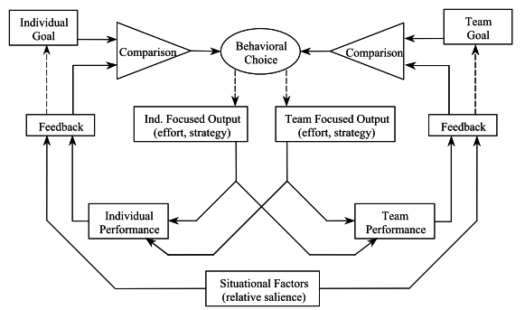

**Figure 3:** Multi goal model of self regulation for effective team regulation.

While Figure 3 shows the behavioral choice of the leader to be a vital component of self regulation and team regulation, very little work has been focused on studying the effect of leader affect on team dynamics. Recently Sy et. al. [27] have demonstrated how important it is for the leader to control and regulate his/her affect cues within dynamical formed teams. The mood of the leader percolates through the team and can have net positive or negative effect on the team outlook and performance. The dynamic nature of team formation is further complicated in medical teams as the responsibility shifts very quickly from one specialist to another as they operate on the patient [28]. Socio-emotional role play of leaders in such dynamic teams is vital to the execution of the current task and smooth development of the shared mental model.

# State-of-the-art Affect Sensors

Affect represents all the complex emotional changes that occur within the human body to various external and internal stimuli. Various levels of emotional experience are channeled to different parts of the human body [29]. For example, sweating of the hands and the hands going cold with the experience of fear; increased heart beat with anxiety; facial expressions of surprise, fear, anger, etc.; bodily expression of submission, dominance, confusion, etc. all represents various levels of affect representation. These affect changes are directly correlated to the socio-emotional state of individuals and by picking up affect changes in a group, it is possible to study the mutual interactions of teams at a socio-emotional level. The area of affect sensing (formally termed as Affective Computing [30]) is an active area of research and has received tremendous interest in the human computer interface community. Growing number of researchers are migrating to brain computer interfacing through affect monitoring [31] [32] as the future of human machine interaction. In the following sections, the two important classes of affect sensing are discussed in detail.

## 3.1 On-body Physiological Sensors:

On-body physiological monitoring refers to the use of invasive sensors that are worn such that the sensing elements are in contact with the skin. These sensors mostly rely upon the various electrical, cardiovascular and kinesthetic actuations in the human body to record the state of the individual. The area of human physiological sensing is relatively new and the possible uses for these sensors have multiplied many folds in the past decade [33]. Figure 4 shows some of the important on-body sensors that are used frequently in healthcare monitoring of individuals.

In healthcare physiological sensors have been used at various levels of assessing individuals [34]. Stress analysis (both physical [35] and mental [36] [37]), Assessing the cardiovascular health of an individual [38], Kinesthetic rehabilitation [39], Diagnosing respiratory conditions, Battlefield monitoring of soldiers [40], sleep monitoring [41] and Health gaming interfaces [42] represent some of the most important healthcare related applications for on-body physiological monitoring. From the perspective of this report, we are interested in measuring the emotional state of individuals who are working in stressful environments. Researchers in the past have used physiological sensors to assess the states of individuals successfully in controlled functional conditions [43] [44].

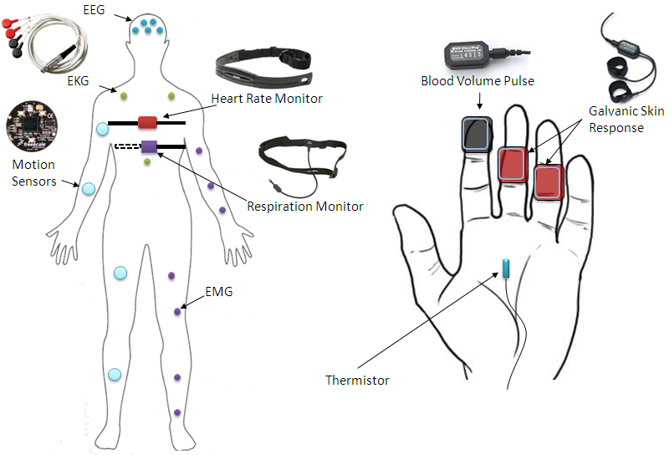

**Figure 4:** Various physiological sensors and their approximate locations on the human body.

## 3.2 Environment-based Affect Sensors:

Figure 5 shows the affect communication in humans as a function of the amount of non-verbal information displayed (y-axis) and the leakiness of the corresponding channel (x-axis). Leakiness here refers to how much control individuals have on expressing their emotion or affect through a specific channel. Higher the leakiness less is one’s control on displaying their emotions. As seen from the figure, untrained humans display their emotions through their voice before any other channel and most amount of non-verbal affective information can be extracted from an individual’s face (42%). Following the face, the body displays a larger segment of the affect information followed by voice.

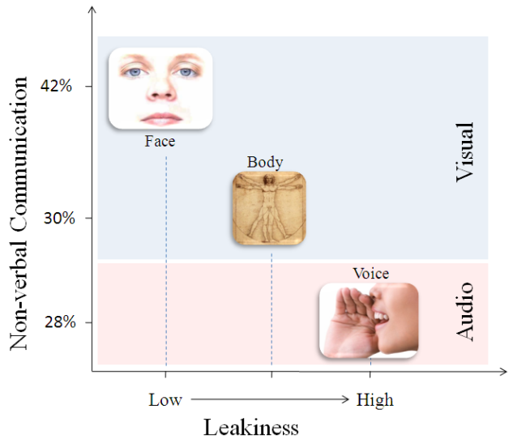

**Figure 5:** Affect communication through non-verbal channels plotted on two independent axis of the amount of information displayed vs. the leakiness of the channel [18].

From the above figure, it can be seen that vision and audio sensors placed in the environments of individuals can be effectively used to extract affect cues that are communicated through the face, body and voice. Historically, cameras have been used for the visual sensing and microphones embedded in the environment offer the audio streams for achieving the necessary affect analysis. The popularity of the vision and audio techniques has skyrocketed in the recent past and various techniques have been demonstrated for application specific affect recognition. Zeng et. al. [45] [46] have produced a detailed survey of affect recognition techniques that have been popular in the literature. These articles provide a detailed analysis of the audio-visual space of affect recognition with their corresponding areas of application. In this report, we will focus on the role for audio-visual affect in addressing the three important research activities as mentioned in the next section.

### 3.2.1 Video-based Affect Recognition:

As mentioned earlier, video-based affect recognition systems mostly rely upon the human face for extracting important emotional cues displayed through facial expressions and gestures. Given a video sequence, the facial mannerism are extracted through a hierarchical tracking system that allows for detection faces present in the video sequence, tracking the faces continuously, detecting various permanent facial features on the detected faces, tracking changes in the facial features and finally decoding the facial expressions. Further, most algorithms also intend to combine the facial expressions with the mannerisms of the head itself to correlate the information. Models for translating facial expressions and head mannerisms into socio-emotional state of the individual are still an actively researched area. Application specific emotional analysis has yielded some success, but generic models of human emotion are far from complete.

Face and Person Detection

Group or Team Composition Analysis

Face or Person Recognition

Facial Feature Extraction

Expression Recognition

Body Part Segmentation

Body Mannerism Analysis

Face and Head Pose Analysis

Socio-Emotion/ Affect Analysis

Leadership

Group Dynamics

Non-Verbal Communication Primitives

Camera

**Figure 6:** Flow chart for video-based affect analysis and how they contribute to the development of the proposed team analysis.

Figure 6 shows the proposed pipeline of video processing algorithms for addressing the proposed team analysis research. At the Center for Cognitive Ubiquitous Computing (CUbiC), we have been working on extracting socio-emotional primitives from video-based systems towards developing social interaction assistant devices for people who are blind and visually impaired ( ). Most of the components related to the extraction of the socio-emotional primitives have been achieved to a certain level of performance . The proposed research activity in this report will focus on integrating individual affect primitives in a group context to understand the nature of team performance.

### 3.2.2 Audio-based Affect Recognition:

Audio based affect systems were derivatives speech recognition and speaker identification problems, which have reached a certain level of maturity and commercial market appeal. While affect recognition through audio relies on feature analysis similar to speech recognition systems, unlike speech recognition, where the algorithms are identifying underlying phonemes in the speech, affect recognition systems focus on the prosody and intonations in the speaker voice. Thus, speech primitives (phonemes) are not the same as the voice primitives (prosody and intonations) [53].

Basic feature extraction – Amplitude, Power, Noise etc.

Time Series Analysis

Speech Primitives

Speaker Identification

Socio-Emotional Affect Primitives

Number of Speakers in the team

Group Dynamics

Prosody

Voice Primitives

Microphone

**Figure 7:** Audio-based affect analysis towards understanding group dynamics.

Various techniques have been suggested in the literature (Please see [46] for details) that follows the basic ides presented by Figure 7. One specific implementation of the audio-based affect monitoring proposed by Pentland’s group at MIT, termed as the Sociometric Badge [54] [55] [56], relies upon the voice primitives with other informal metrics (like how many time each individual interacted face-to-face with others, what was the overall emotional exchange between individuals, how long one dominated a meeting, etc.) to evaluate a social map of organizations. The social maps act as a medium for communicating team formations and increasing overall performance of a group.

# 4. Research Activities:

The following research activities addressed below will be carried out in the state-of-the-art Mayo Clinic Multidisciplinary Simulation Center, Phoenix AZ. Residents, doctors and technicians will volunteer to simulate various medical emergency codes on computer aided mannequins, such as Gaumard’s S3000 HAL® Mobile Team Trainer, Progressive Medical International’s ALS team trainer etc. On-body physiological sensors will be placed on individuals who participate in execution of the medical code. To begin, only three participants (chosen before hand) will be monitored on the physiological systems. The team itself will be monitored through a series of environmentally embedded cameras and microphones to capture all visual and audio patterns within the room. The setup and the associated technologies are described below in detail.

## 4.1 The Mayo Clinic Multidisciplinary Simulation Center:

The Mayo Clinic Multidisciplinary Simulation Center provides many advantages in learning team performance and hospital emergency code training. The center was designed to reflect the complexity of the live clinical environment. The physical, electronic, microcultural and macrocultural environments were key elements to be replicated in order to create a practice field for clinical situations. The physical environment was replicated including artifacts such as the bed, sink, cabinets, flooring, doors and lights. The electronic environment replicated with monitors, intravenous pumps, electronic medical record, pharmaceutical dispensing system, decision support software and computers. Promoting interprofessional team training facilitated replication of the microcultural environment and imbedding the simulation center within the hospital facilitated the macroculture environment. The patient clinical situations were replicated by combinations of high fidelity simulators, virtual reality simulators, standardized patient actors, and low fidelity simulators. Experts developed standardized simulation scenarios, curriculum and debriefing specific to learner or team performance level.

Within this environment, a high resolution audio and video capture system was unobtrusively placed for performance monitoring and archiving. Data was saved to an internet based learning management system with individual and team portolios permitting immediate local or asynchronous remote review and feedback. Teams practice rare or life threatening event management in an error-forgiving environment gaining experiences which have been shown to improve patient safety [57]. In addition, ‘Crisis Resource Management’ principles are applied to leadership, situational awareness and communication training.

* Hospital based center with clinical microsystems reflecting the live environment
* High fidelity simulators, virtual reality trainers, simulated electronic medical record
* Wireless biometric monitoring and audio-video architecture for simulation suites, in situ, and in vivo performance archive
* Internet based learning management system with individual and interprofessional team portfolios
* Expert developed standardized curriculum and debriefing
* Curriculum customized to learner or team performance level
* Error-forgiving clinical experience, enhancing patient safety
* Deliberate practice with supervised instruction in life-threatening events management
* Experience with uncommon scenarios
* Leadership training and debriefing using “Crisis Resource Management” principles

## 4.2 Automated monitoring of group dynamics to determine communication breakdowns

Current team performance analysis systems are mostly based on retrospective analysis of the video streams collected during simulations of hospital emergency codes. The analyses are mostly based on expert’s opinion of what happened during critical incidents of the simulation [58] [59]. Unfortunately, expert’s time is very valuable and post-simulation analysis may not get enough attention due to increased hospital load. For long, researchers have asked how communication between medical team members varies over the period of the emergency code execution [60], but very little is understood on the basics of the communication during emergency due to the lack of an annotation system that does not require costly specialist time beyond the simulations. This research task will focus on developing an automated team performance analysis system that will focus on detecting specific points within the audio-video capture where communication breakdown occurred during code simulation. This automated annotation will directly relate to the following research hypothesis:

### 4.2.1 Research Hypothesis:

Team performance is diminished in medical groups that have reduced interpersonal communication due to increased emotional stress in one or more individuals.

### 4.2.2 Research Methodology:

Hospital emergency codes will be executed on teams of doctors, nurses and residents on weekly and/or monthly basis. During these codes audio, visual and individual physiological data will be collected on each of the individual that enters the code simulation. The data collected during the simulations will be used for assessing two important aspects of the team members, a) The physiological state (emotional state and stress of the individuals), and b) The overall communication between the participants. Based on the methods proposed in Section 3.2.1 and 3.2.2, communicative dynamics among the team members will be extracted automatically. Inter specialist communications will be annotated along with the corresponding socio-emotional state of the individuals. The automated annotations will be used for correlating the team simulation performance with the communicative gestures and socio-emotional states of the individuals. The research hypothesis 4.2.1 will be tested against the annotations captured during code simulations.

### 4.2.3 Impact on TeamSTEPPS:

This research question will directly affect the Communication component of the TeamSTEPPS training. These analyses could be used as TeamSTEPPS is adopted by the hospital. Thus, any progress in communication as team skills can be automatically monitored.

## 4.3 Automatic evaluation of the social affinity between team members

Sociograms (social affinity maps) have been used historically to determine the interpersonal match between members of a team or an organization. Sociograms are obtained through the process of sociometry, which quantitatively measures the relationships of individuals who exist within a social space. As mentioned earlier, in medical teams, the social space happens to be the emergency room where the team assembles with very little or no time to assess who are the members of the team. Sociometry is achieved through a set of evaluations that can assess the social interactions between individuals. The measurements could happen within the environment where the individuals interact (the medical team) or outside (casual interactions). Sociometric badges [61] provide parameters that could in turn provide quantitative evaluations of the social interactions between individuals.

Sociograms developed at a hospital level could offer effective tools for quick team formations. Teams formed out of specialists, technicians and nurses who are closer to one another on the sociogram could offer a better team, with relatively lesser emotional stress induced due to the emergency code. Socially closer individuals will also exhibit improved social interactions and hence better communication, thereby increasing team performance. Automated sociograms for emergency response individuals within a hospital can provide an effective tool for gathering performing team members when an emergency situation arises. The automated sociogram generation directly relates to the following research hypothesis:

### 4.3.1 Research Hypothesis:

Medical teams formed through sociometric evaluation of individuals will have a better team performance and less emotional stress when compared to *ad hoc* teams.

### 4.3.2 Research Methodology:

The methodology is very similar to the one defined in Section 4.2.2. Audio-visual and physiological data will be collected on each member of teams performing code simulations within the simulator. Sociograms will be generated based on the inter person communication within and outside the simulation environments. The research hypothesis will be tested by the comparing the performance of teams that are assembled at random with that of teams developed based on sociograms.

### 4.3.3 Impact on TeamSTEPPS:

By forming teams with members (with complimentary functional roles) that are closer to each other on the sociogram, it may be possible to increase the mutual support and situation monitoring abilities of their partners. Individuals who think and react similarly (as predicted by sociograms) may be able to predict situations and circumstances faced by their team members during emergency conditions. Backup behavior may evolve automatically in team members selected from the sociograms.

## 4.4 Leadership evaluation and nomination through long term monitoring of teams and individuals

As discussed in Section 2.2, leadership is an important component of efficiently performing teams. The higher team performance can directly be correlated to the ability of the leader in the team to take charge of situations, such as provide backup, organize team based on each medical professional in the team, communicate without any confusion about his/her intent to the team, resolve conflict of opinions or ideas, etc.

### 4.4.1 Research Hypothesis:

Medical teams created with a leader (indentified by their performances in earlier *ad hoc* teams) will deliver better team performance with reduced emotional stress on the individual team members.

### 4.4.2 Research Methodology:

Random teams created *ad hoc* will be evaluated with the performance of teams that are created based on their past performance – not only in their functional performance, but on their ability to communicate, provide mutual support and backup and offer appropriate team support. Based on the individual’s ability to control their socio-emotional stress, while attending emergency simulations, it may be possible to identify individuals who are able to control, coordinate and moderate teams better. Long term monitoring of these individuals in different group settings could enable automated identifying of effective team leaders.

### 4.4.3 Impact on TeamSTEPPS:

Automated leadership identification during training of teams on hospital emergency codes.

# Conclusion:

Sensor based evaluation of the socio-behavioral dynamics within medical teams could have promise in understanding the nature of team performance. Along with determining individual’s internal stress through physiological monitoring, we could discover the mutual stress within professional teams. Using the multidisciplinary Mayo Clinic simulator, we propose to understand the three important attributes of teams that will directly affect TeamSTEPPS training. These include a) the ability to automatically determine communication breakdowns in medical teams, b) Automated discovery of social affinity between team members, thereby allowing us to develop teams that have better mutual support and situation monitoring, and, 3) Automated identification of leadership qualities in individuals who work with ad hoc medical teams.

**Bibliography:**

[1] Linda T. Kohn, Janet M. Corrigan, and Molla S. Donaldson, Editors; Committee on Quality of Health Care in America, Institute of Medicine, *To Err Is Human: Building a Safer Health System*, Washington, D.C.: The National Academies Press, 2000.

[2] *Quality Interagency Coordination Task Force. Doing What Counts for Patient Safety: Federal Actions to Reduce Medical Errors and Their Impact.*, Washington, D.C.: 2000.

[3] C. Clancy, “AHRQ: a tradition of evidence: federal agency carries a rich history of involvement in today's evidence-based medicine movement, focusing on the "evidence" inside healthcare IT - Evidence-Based Medicine,” 2003.

[4] H. King, J. Battles, D. Baker, A. Alonso, E. Salas, J. Webster, L. Toomey, and M. Salisbury, “TeamSTEPPS ™ : Team Strategies and Tools to Enhance Performance and Patient Safety,” *Advances in Patient Safety: From Research to Implementation*, vol. 3.

[5] S. Powell, *TeamSTEPPS™- Strategies and Tools to Enhance Performance and Patient Safety: A Collaborative Initiative for   
Improving Communication and Teamwork in Healthcare*, Fayetteville, GA: Healthcare Team Training, LLC, 2009.

[6] E.L. Wiener, B.G. Kanki, and R.L. Helmreich, *Cockpit Resource Management*, Academic Press, 1995.

[7] D. Baker, S. Gustafson, J. Beaubien, E. Salas, and P. Barach, *Medical teamwork and patient safety: The evidence-based relation.*, Washington, DC:: American Institutes for Research, 2003.

[8] E. Salas, C.S. Burke, and K.C. Stagl, “Developing teams and   
team leaders: Strategies and principles.,” *Leader development for transforming organizations.*, R.G. Demaree, S.J. Zaccaro, and S.M. Halpin, Eds., Mahwah, NJ: Lawrence Erlbaum Associates, Inc., 2004, pp. 325-358.

[9] P. Barach and M. Weingart, “Trauma team performance,” *Trauma: Resuscitation, Anesthesia and Critical Care*, W.C. Wilson, C.M. Grande, and D.B. Hoyt, Eds., Informa Healthcare, 2007, pp. 96-150.

[10] R.M. McIntyre and E. Salas, “Measuring and managing for team performance: Emerging principles from complex environments.,” *Team Effectiveness and Decision Making in Organizations*, R.A. Guzzo and E. Salas, Eds., San Francisco: Jossey-Bass, 1995, pp. 194-203.

[11] J.A. Cannon-Bowers, S.I. Tannenbaum, and E. Salas, “Defining competencies and establishing team training requirements.,” *Team Effectiveness and Decision Making in Organizations*, R.A. Guzzo and E. Salas, Eds., San Francisco: Jossey-Bass, 1995, pp. 333-380.

[12] J.E. Driskell and E. Salas, “Collective behavior and team performance,” *Hum. Factors*, vol. 34, 1992, pp. 277-288.

[13] V.L. Patel, J. Zhang, N.A. Yoskowitz, R. Green, and O.R. Sayan, “Translational cognition for decision support in critical care environments: a review,” *Journal of Biomedical Informatics*, vol. 41, Jun. 2008, pp. 413-431.

[14] D. Bandon, “Time to create sound teamwork,” *Journal of Qualitative Participation*, vol. 24, 2001, pp. 41-47.

[15] D. Forsyth, *Group dynamics*, Belmont CA: Thomson/Wadsworth, 2006.

[16] J.L. Moreno, *Sociometry, Experimental Method and the Science of Society*, Beacon House, 1983.

[17] M.L. Knapp and J.A. Hall, *Nonverbal Communication in Human Interaction*, Harcourt College Pub, 1996.

[18] N. Ambady and R. Rosenthal, “Thin Slices of Expressive behavior as Predictors of Interpersonal Consequences : a Meta-Analysis,” *Psychological Bulletin*, vol. 111, 1992, pp. 274, 256.

[19] A.(. Pentland, “Automatic mapping and modeling of human networks,” *PHYSICA A*, 2006.

[20] T. Kim, D.O. Olguin, B.N. Waber, and A.(. Pentland, “Sensor-Based Feedback Systems in Organizational Computing,” *Computational Science and Engineering, IEEE International Conference on*, Los Alamitos, CA, USA: IEEE Computer Society, 2009, pp. 966-969.

[21] L. Mann and A. Pirola-Merlo, “The relationship between individual creativity and team creativity: aggregating across people and time,” *Journal of Organizational Behavior*, vol. 25, pp. 235-257.

[22] J. Gardin, “Computer-Supported Cooperative Work: history and focus,” *Computer*, vol. 27, 1994, pp. 19-26.

[23] G.B. Chapman and F.A. Sonnenberg, *Decision Making in Health Care: Theory, Psychology, and Applications*, Cambridge University Press, 2003.

[24] B.W. Tuckman, “Developmental sequence in small groups,” *Psychological Bulletin*, vol. 63, 1965, pp. 384-399.

[25] U. Hess and P. Philippot, *Group Dynamics and Emotional Expression*, Cambridge University Press, 2007.

[26] S.W.J. Kozlowski, S.M. Gully, P.P. McHugh, E. Salas, and J.A. Cannon-Bowers, “A dynamic theory of leadership and team effectiveness: Developmental and task contingent leader roles.,” *Research in Personnel and Human Resources Management*, G. Ferris, Ed., JAI Press, 1996, pp. 252-305.

[27] T. Sy, S. Côté, and R. Saavedra, “The contagious leader: impact of the leader's mood on the mood of group members, group affective tone, and group processes,” *The Journal of Applied Psychology*, vol. 90, Mar. 2005, pp. 295-305.

[28] Cooper S.[1] and Wakelam A., “Leadership of resuscitation teams: 'Lighthouse Leadership',” *Resuscitation*, vol. 42, Sep. 1999, pp. 27-45.

[29] D. Keltner and J. Haidt, “Social Functions of Emotions at Four Levels of Analysis,” *Cognition and Emotion*, vol. 13, Sep. 1999, pp. 505-521.

[30] R.W. Picard, *Affective Computing*, The MIT Press, 2000.

[31] J.J. Vidal, “Toward Direct Brain-Computer Communication,” *Annual Review of Biophysics and Bioengineering*, vol. 2, 1973, pp. 157-180.

[32] R. Matthews, P.J. Turner, N.J. McDonald, K. Ermolaev, T. McManus, R.A. Shelby, and M. Steindorf, “Physiological Sensor Suite Using Zero Preparation Hybrid Electrodes for Real Time Workload Classification,” *ITEA Journal*, vol. 30, 2009, pp. 13- 17.

[33] E. Monton, J. Hernandez, J. Blasco, T. Herve, J. Micallef, I. Grech, A. Brincat, and V. Traver, “Body area network for wireless patient monitoring,” *Communications, IET*, vol. 2, 2008, pp. 215-222.

[34] A. Lymberis and A. Dittmar, “Advanced Wearable Health Systems and Applications - Research and Development Efforts in the European Union,” *Engineering in Medicine and Biology Magazine, IEEE*, vol. 26, 2007, pp. 29-33.

[35] S. Linder, S. Wendelken, and J. Clayman, “Detecting Exercise Induced Stress using the Photoplethysmogram,” *Engineering in Medicine and Biology Society, 2006. EMBS '06. 28th Annual International Conference of the IEEE*, 2006, pp. 5109-5112.

[36] R. Cooper, J. Al-Muhtadi, and R. Ashford, “Smart Spaces with Real-Time Physiological Measurement and Mitigation of Stress,” *Pervasive Computing and Applications, 2008. ICPCA 2008. Third International Conference on*, 2008, pp. 3-8.

[37] J. Healey and R. Picard, “Detecting stress during real-world driving tasks using physiological sensors,” *Intelligent Transportation Systems, IEEE Transactions on*, vol. 6, 2005, pp. 156-166.

[38] R. Ladysz, T. Fabiszak, W. Pospiech, M. Pilaczynska-Cemel, and J. Kubica, “Detection of Cardiac-Related Diseases Using Nonlinear Analysis of Short-Term ECG Signal with Aural Stimuli,” *Systems Engineering, 2008. ICSENG '08. 19th International Conference on*, 2008, pp. 557-559.

[39] B. Jarochowski, SeungJung Shin, DaeHyun Ryu, and HyungJun Kim, “Ubiquitous Rehabilitation Center: An Implementation of a Wireless Sensor Network Based Rehabilitation Management System,” *Convergence Information Technology, 2007. International Conference on*, 2007, pp. 2349-2358.

[40] Dae-Ki Cho, Chia-Wei Chang, Min-Hsieh Tsai, and M. Gerla, “Networked medical monitoring in the battlefield,” *Military Communications Conference, 2008. MILCOM 2008. IEEE*, 2008, pp. 1-7.

[41] Jae Hyuk Shin, Young Joon Chee, Do-Un Jeong, and Kwang Suk Park, “Nonconstrained Sleep Monitoring System and Algorithms Using Air-Mattress With Balancing Tube Method,” *Information Technology in Biomedicine, IEEE Transactions on*, vol. 14, 2010, pp. 147-156.

[42] B. Sawyer, “From Cells to Cell Processors: The Integration of Health and Video Games,” *Computer Graphics and Applications, IEEE*, vol. 28, 2008, pp. 83-85.

[43] L. Rothkrantz, R. van Vark, and D. Datcu, “Multi-medial stress assessment,” *Systems, Man and Cybernetics, 2004 IEEE International Conference on*, 2004, pp. 3781-3786 vol.4.

[44] P. Zappi, T. Stiefmeier, E. Farella, D. Roggen, L. Benini, and G. Troster, “Activity recognition from on-body sensors by classifier fusion: sensor scalability and robustness,” *Intelligent Sensors, Sensor Networks and Information, 2007. ISSNIP 2007. 3rd International Conference on*, 2007, pp. 281-286.

[45] Z. Zeng, M. Pantic, G.I. Roisman, and T.S. Huang, “A survey of affect recognition methods: audio, visual and spontaneous expressions,” *Proceedings of the 9th international conference on Multimodal interfaces*, Nagoya, Aichi, Japan: ACM, 2007, pp. 126-133.

[46] Z. Zeng, M. Pantic, G.I. Roisman, and T.S. Huang, “A Survey of Affect Recognition Methods: Audio, Visual, and Spontaneous Expressions,” *IEEE Trans. Pattern Anal. Mach. Intell.*, vol. 31, 2009, pp. 39-58.

[47] S. Krishna, D. colbry, J. Black, V. Balasubramanian, and S. Panchanathan, “A Systematic Requirements Analysis and Development of an Assistive Device to Enhance the Social Interaction of People Who are Blind or Visually Impaired,” *Workshop on Computer Vision Applications for the Visually Impaired*, Marseille, France: 2008.

[48] S. Krishna, T. McDaniel, and S. Panchanathan, “Haptic Belt for Delivering Nonverbal Communication Cues to People who are Blind or Visually Impaired,” *25th Annual International Technology & Persons with Disabilities*, Los Angeles, CA: 2009.

[49] S. Krishna, S. Bala, T. McDaniel, S. McGuire, and S. Panchanathan, “VibroGlove: an assistive technology aid for conveying facial expressions,” *Proceedings of the 28th of the international conference extended abstracts on Human factors in computing systems*, Atlanta, Georgia, USA: ACM, 2010, pp. 3637-3642.

[50] T. McDaniel, S. Krishna, V. Balasubramanian, D. Colbry, and S. Panchanathan, “Using a haptic belt to convey non-verbal communication cues during social interactions to individuals who are blind,” *Haptic Audio visual Environments and Games, 2008. HAVE 2008. IEEE International Workshop on*, 2008, pp. 13-18.

[51] T.L. McDaniel, S. Krishna, D. Colbry, and S. Panchanathan, “Using tactile rhythm to convey interpersonal distances to individuals who are blind,” *Proceedings of the 27th international conference extended abstracts on Human factors in computing systems*, Boston, MA, USA: ACM, 2009, pp. 4669-4674.

[52] S. Krishna, T. McDaniel, and S. Panchanathan, *Embodied Social Interaction Assistant*, Tempe, USA: Arizona State University, 2010.

[53] R. Barra, J.M. Montero, J. Macías-guarasa, L.F. D’haro, R. San-segundo, and R. Córdoba, “Prosodic and segmental rubrics in emotion identification,” *PROC. OF ICASSP*, 2006, pp. 1085--1088.

[54] D.O. Olguín and A. Pentland, “Sensible Organizations: A Sensor-Based System for Organizational Design and Engineering,” 2009.

[55] D. Olguin Olguin, B.N. Waber, T. Kim, A. Mohan, K. Ara, and A. Pentland, “Sensible organizations: technology and methodology for automatically measuring organizational behavior,” *IEEE Transactions on Systems, Man, and Cybernetics. Part B, Cybernetics: A Publication of the IEEE Systems, Man, and Cybernetics Society*, vol. 39, Feb. 2009, pp. 43-55.

[56] D.O. Olguín and A.(. Pentland, “Social Sensors for Automatic Data Collection,” 2008.

[57] R.R. Seethala, E.C. Esposito, and B.S. Abella, “Approaches to improving cardiac arrest resuscitation performance,” *Current Opinion in Critical Care*, vol. 16, 2010, pp. 196-202.

[58] K. Karlgren, A. Dahlström, and S. Ponzer, “Design of an Annotation Tool to Support Simulation Training of Medical Teams,” *Times of Convergence. Technologies Across Learning Contexts*, 2008, pp. 179-184.

[59] D.N. Carbine, N.N. Finer, E. Knodel, and W. Rich, “Video recording as a means of evaluating neonatal resuscitation performance,” *Pediatrics*, vol. 106, Oct. 2000, pp. 654-658.

[60] E. Bergs, F. Rutten, T. Tadros, P. Krijnen, and I. Schipper, “Communication during trauma resuscitation: do we know what is happening?,” *Injury*, vol. 36, 2005, pp. 905-911.

[61] B.N. Waber, D.O. Olguin, T. Kim, A. Mohan, K. Ara, and A. Pentland, “Organizational Engineering Using Sociometric Badges,” *SSRN eLibrary*, May. 2007.